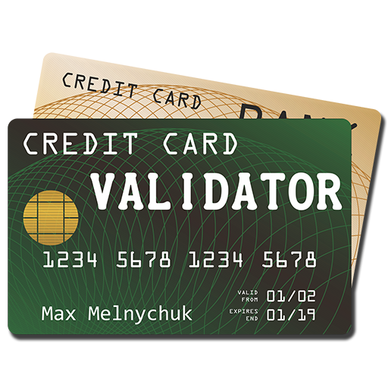

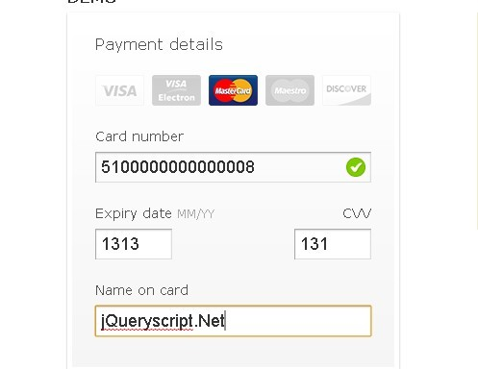

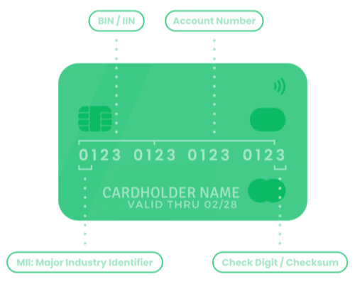

# International StandardBookNumber(ISBN)

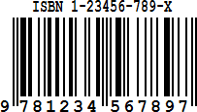

DEFINITION: ISBN, or International Standard Book Number, is a unique identifier assigned to books. It is a 10 or 13-digit number that is used to identify and track books globally.

The ISBN is designed to help booksellers, publishers, libraries, and other organizations to manage their inventory and facilitate international trade.

APPLICATION: ISBNs are used in a variety of ways, including on book covers, in catalogs and databases, and online retailers. They are also used to identify books in library systems and for ordering books from publishers and distributors.

EXPLAINATION: The ISBN-10 code is made up of four parts: the first part is the country code, the second part is the publisher code, the third part is the title code, and the fourth part is the check digit. The check digit is used to confirm the validity of the ISBN-10 code. ISBN-10 codes are still in use, but many publishers have switched to using ISBN-13 codes

## What would be difficult without it?

Without ISBN 10, it would be difficult to identify and track books globally, which would make it harder to manage inventory and facilitate international trade. It would also make it more difficult to order books and manage data about them, which would make it harder for publishers and other organizations to make informed decisions. This will lead to more inefficiencies and errors in the book industry.

### How does discrete structure solve this authentication digital check problem?

ISBN 10 uses a specific algorithm based on modulo arithmetic, specifically modulo 11, to calculate the check digit of ISBN.

### ALGORITHM:

The specific algorithm used to calculate the check digit for ISBN 10 is as follows:

1. Multiply the first digit of the ISBN by 10, the second digit by 9, the third digit by 8, and so on, until the last digit.
2. Sum up all the results obtained in step 1.
3. Take modulo 11 of the result obtained in step 2. 4. Subtract the result obtained in step 3 from 11.

5. If the result obtained in step 4 is equal to 10, the check digit is denoted as "X". If the result is between 0 and 9, the result is used as the check digit.

### EXAMPLE:

For example, if the ISBN is 0-306-40615-X, the check digit calculation would be as follows:

1. (0 x 10) + (3 x 9) + (0 x 8) + (6 x 7) + (4 x 6) + (0 x 5) + (6 x 4) + (1 x 3) + (5 x 2) = 0 +

27 + 0 + 42 + 0 + 0 + 24 + 3 + 10 = 106

2. 106 mod 11 = 7

3. 11 - 7 = 4 the check digit is 4, which matches the last digit in the ISBN, so it is a valid ISBN.

OUTPUT:

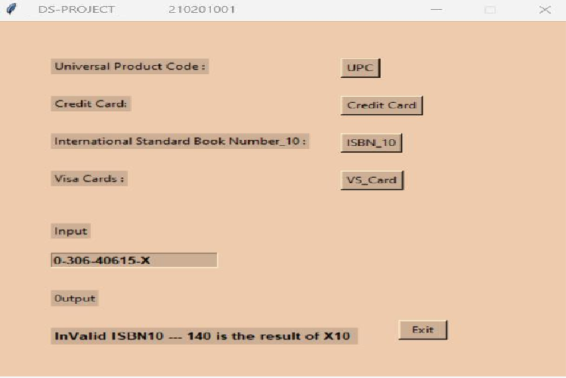

# UNIVERSALPRODUCTCODE(UPC)

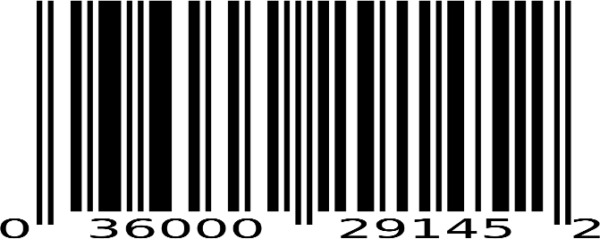

DEFINITION: A Universal Product Code (UPC) is a barcode that is widely used in the United States, Canada, and other countries for tracking trade items in stores.

APPLICATION: UPCs are used to track products from the manufacturer to the point of sale, helping to ensure efficient and accurate inventory management. UPCs are used in many retail sectors including supermarkets, department stores, and electronic stores. UPCs are used globally.

EXPLAINATION: UPCs consists of a 12-digit number that is unique to each product and is encoded in a barcode format that can be scanned by a barcode scanner. The first six

digits of the UPC are the manufacturer's identification number, and the last six digits are the product's identification number.

## What would be difficult without it?

UPCs play a vital role in ensuring efficient and accurate tracking of products in retail and supply chain management, and their absence would make many aspects of these industries more difficult. Retailers and manufacturers would not be able to track sales data without a unique identifier for each product, stores would likely have to rely on manually entering product information at the point of sale, which would be time- consuming and prone to errors.

### How does discrete structure solve this authentication digital check problem?

One common algorithm used to calculate the check digit in UPC is called the Modulo 10 algorithm.

### ALGORITHM:

The specific algorithm used to calculate the check digit for UPC is as follows:

1. Add the digits in the odd-numbered positions (first, third, fifth, etc.) together and multiply by three.
2. Add the digits (up to but not including the check digit) in the even-numbered positions (second, fourth, sixth, etc.) to the result.
3. Take the remainder of the result divided by 10 (modulo operation) and if not 0, subtract this from 10 to derive the check digit.
4. If the check digit and answer of the calculation are the same the barcode scanned is most likely valid.

### EXAMPLE:

For example, if the UPC is 036000291452, the check digit calculation would be as follows: 1. (0+6+0+2+1+5) x 3 + (3+0+0+9+4) =58

2. 58 mod 10 = 8 > 0

3. 10 - 8 = 2 the check digit is 2, which matches the last digit in the UPC, so it is a valid UPC.

OUTPUT

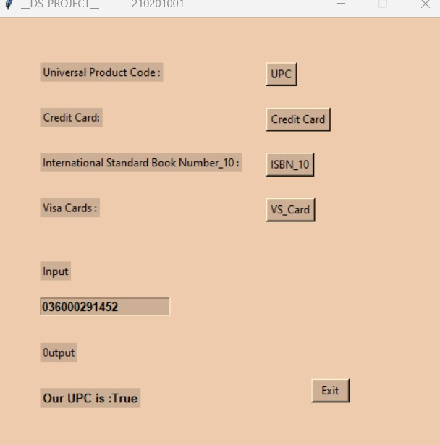

# MASTERCARD

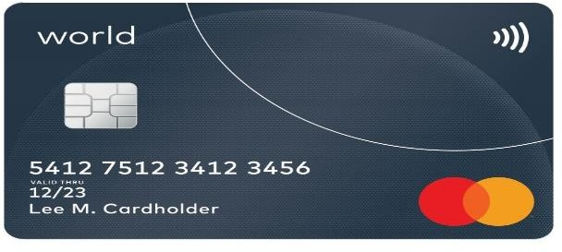

DEFINITION: MasterCard is a global payment technology company that operates one of the most widely accepted payment card networks in the world. MasterCard offers a range of payment products and services, including credit cards, debit cards, and prepaid cards.

APPLICATION: MasterCard is a widely accepted payment method that can be used for a wide range of transactions and services, both for consumers and businesses. Also used for cash withdrawals at ATMs, and for online payments on websites that accept MasterCard.

EXPLAINATION: MasterCard credit card numbers are made up of 16 digits. The first digit of the card number is the "industry identifier", and the remaining digits are the "bank identification number" (BIN) and "account number". The last digit of the credit card

number is the check digit, which is calculated using a specific algorithm based on modulo arithmetic.

## What would be difficult without it?

MasterCard is an important form of payment, and without it, many businesses and individuals would find it difficult to make purchases and transactions. It provides purchasing power, financial options, security against fraud, and ease of use for international transactions and e-commerce. Limited financial options and reduced purchasing power would arise without MasterCard.

### How does discrete structure solve this authentication digital check problem?

One common algorithm used to calculate the check digit in MasterCard is called the Luhn algorithm, also known as the "mod 10" algorithm.

### ALGORITHM:

The specific algorithm used to calculate the check digit for Master Card is as follows:

1. Starting from the rightmost digit (the check digit) and moving left, double the value of every second digit
2. For any digits that become 10 or more, subtract 9 from the result. 3. Sum all the digits together.

4. Take modulo 10 of the sum obtained in step 3. If the result is equal to 0, the credit card number is valid. If not, it is invalid.

### EXAMPLE:

For example, if the Master Card number is 5105105105105100, the check digit calculation would be as follows:

1

.(5 x 2) = 10, (1 x 2) = 2, (0 x 2) = 0, (5 x 2) = 10, (1 x 2) = 2, (0 x 2) = 0, (5 x 2) = 10, (1 x

2) = 2, (0 x 2) = 0, (5 x 2) = 10, (1 x 2) = 2, (0 x 2) = 0, (0 x 2) = 0

2. 10-9=1, 10-9=1, 10-9=1, 10-9=1, 10-9=1, 10-9=1, 10-9=1, 10-9=1, 10-9=1

3. 1+0+5+1+0+5+1+0+5+1+0+5+1+0+0 = 23

1. 23 mod 10 = 0. The result is equal to 0, so the Master Card credit card number is valid.

OUTPUT:

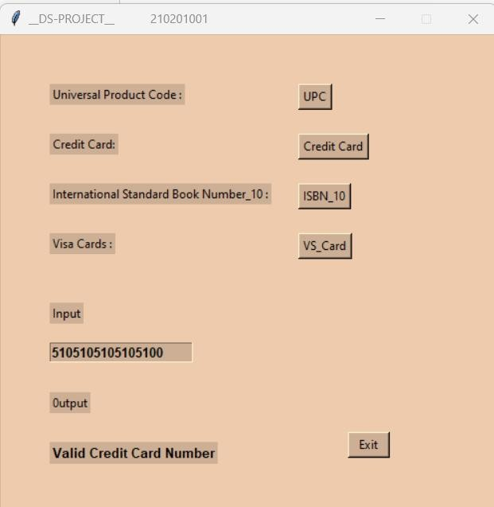

# VISACARD

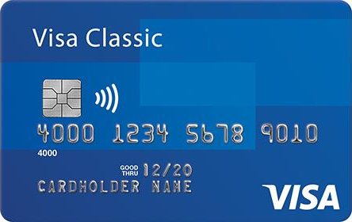

DEFINITION: A Visa card is a type of credit or debit card that is issued by Visa Inc., a global payments technology company. The cards can be physical cards or digital cards and can be linked to a checking account, savings account, or credit account.

APPLICATION: Visa cards can be used to make purchases at merchants, online, or over the phone, and also for cash withdrawals from ATMs. Visa cards have a wide range of applications and are used in various ways, some of the most common ways include:

* + Point-of-Sale (POS) Transactions
  + Online payments
  + Rewards and incentives
  + Cash withdrawals
  + Recurring payments

EXPLANATION: Visa credit card numbers are made up of 16 digits. The first digit of the card number is the "industry identifier", and the remaining digits are the "account number". The last digit of the credit card number is the check digit, which is calculated using a specific algorithm based on modulo arithmetic.

## What would be difficult without it?

Without Visa cards, many individuals and businesses would find it difficult to make purchases and transactions. Some of the difficulties that would arise without Visa cards are reduced purchasing power, limited financial options, difficulty in E-commerce, difficulty in international transactions, and increased fraud risk.

### How does discrete structure solve this authentication digital check problem?

One common algorithm used to calculate the check digit in Visa Card is called the Luhn algorithm, also known as the "mod 10" algorithm.

### ALGORITHM:

The specific algorithm used to calculate the check digit for MasterCard is as follows:

1. Starting from the rightmost digit (the check digit) and moving left, double the value of every second digit
2. For any digits that become 10 or more, subtract 9 from the result. 3. Sum all the digits together.

4. Take modulo 10 of the sum obtained in step 3. If the result is equal to 0, the credit card number is valid. If not, it is invalid.

### EXAMPLE:

For example, if the Visa Card number is 4111111111111111, the check digit calculation would be as follows:

1. (4 x 2) = 8, (1 x 2) = 2, (1 x 2) = 2, (1 x 2) = 2, (1 x 2) = 2, (1 x 2) = 2, (1 x 2) = 2, (1 x 2)

= 2, (1 x 2) = 2, (1 x 2) = 2, (1 x 2) = 2, (1 x 2) = 2, (1 x 2) = 2, (1 x 2) = 2, (1 x 2) = 2,(1x2)=

2

2. No digits become 10 or more

3. 8+2+2+2+2+2+2+2+2+2+2+2+2+2+2+2 = 30

4. 30 mod 10 = 3. The result is equal to 0, so the MasterCard credit card number is valid.

OUTPUT:

